# OSPEX fits to CEA calibration spectra

Ewan Dickson Version 1.0   
Univ. Graz (Austria) 14-August-2019

## Introduction

### Fitting Calibration Spectra

Determining the calibration parameters (offset and gain) for every pixel under the full range of conditions which the STIX detectors will experience is necessary for correct science. The quicklook calibration spectra which are accumulated at quite times and contain emission lines from the on-board Barium 133 sources will be telemetered down at regular intervals and must be processed by ground software to extract the current detector calibration parameters.

### Laboratory measurements

The measurements were performed in CEA-Saclay. These measurements were performed in several batches with different detectors on different dates in total 30 detectors were tested including 19 that were ultimately selected for flight (Table 1 from Caliste-SO_laboratory_measurements.doc). The data was processed by CBK Wrocław and the FITS and IDL .sav files were passed to Uni Graz for this study.

Table 1: Detectors used in the testing procedure, and the corresponding identification numbers of units selected for flight.

|  |  |  |  |
| --- | --- | --- | --- |
| Batch | Date (start) | Detectors used | Selected for flight |
| 1 | 24.09.2014 | 23-33-39-49-54-55 | 33-39-54 |
| 2 | 24.09.2014 | 26-27-32-35-46-48 | 26-27-35-48 |
| 3 | 07.10.2014 | 36-40-41-44-47-50-51 | 36-41-51 |
| 4 | 20.01.2015 | 56-57-59-60 | 56-57-59-60 |
| 5 | 26.06.2015 | 76-77-79-80-82-83-98 | 76-77-79-80-82 |

The details such a voltage, Temperature and peaking time of each repetition for the calibration and performance study test procedure are given in Table 2. The testing procedure was performed in the similar manner for each batch. As the temperature was measured on the aluminum plate only rough estimation of the temperature in the detector crystal can be made. It can be assumed that this value is slightly higher -20°C, -15°C, and -10°C, respectively (A. Meuris, reported in Caliste-SO_laboratory_measurements.doc).

Table 2: The testing scheme

|  |  |  |  |  |  |
| --- | --- | --- | --- | --- | --- |
| action | source | temperature  [°C] | duration  [min.] | voltage [V] | peaking time [µs] |
| calibration | Am241 | -40, -30, -20 | 15 (-40°C, -30°C) and 10  (-20°C) | 300 | 1,2,8 |
| performance study | Co57 | -40, -30, -20 | 5 | 200,  300  400 | 1,2,8 |

## Conversion to STIX Telemetry

Results of each repetition were written to FITS files. At CBK they were read in and a conversion to energy scale performed using the formula: energy = (amplitude – offset)/gain.

For a given repetition the FITS files were processed and saved into and IDL sav file which contained:

A structure, d1, containing time, energy and pixel number of each registered event. The information about multiple events was also included in d1 (field ‘multiplicity’).

Information about the action’s parameters: temperature, duration of data gathering, peaking time, voltage, threshold, radioactive source identification, and numbers of detectors used in the action.

These FITS and sav files were then passed to Uni Graz for fitting, parameter extraction and further analysis.

In order to generate telemetry packets the data from performance study was used. The measured amplitude was converted to a nominal energy based on the offset and gain values determined in the CEA calibration testing. Values from data taken by the PFM were used to convert these energies into a typical scale such that the spectrum could then be written in terms of accumulated telemetry counts and passed to the STIX telemetry writer.

All single counts registered in given detector were binned into a histogram divided into 1024 energy channels. The data for each detector and channel was passed into the accumulated_counts array in a standard stx_fsw_m_calibration_spectrum structure.

Subspectra intervals at full resolution of 1024 bins were used here for all cases therefore the parmeters for starting bin, resolution and number of bins for the written subspectra were   
calibration_subspectra = [[0,1,512],[512,1,512]]

the standard values for integer compression were used to ensure that the effects of integer compression on real data would be accurately replicated.

ql_calibration_spectrum_compression_counts = [0b,5b,3b]

The spectra and parameters in the were passed to the IDL FSWS telemetry writer object and written to file

tmtc_writer = stx_telemetry_writer(filename= filename)

tmtc_writer->setdata, ql_calibration_spectrum=stx_fsw_m_calibration_spectrum, solo_packets = solo_packets, $

compression_param_s = ql_calibration_spectrum_compression_counts[0], $

compression_param_k = ql_calibration_spectrum_compression_counts[1], $

compression_param_m = ql_calibration_spectrum_compression_counts[2], $

subspectra_definition = calibration_subspectra

tmtc_writer->flushtofile

## Fitting procedure

The fitting of the calibration lines is performed by a modified version of the script stx_calib_fit. So the procedure is similar to what will be performed on the real telemetry data received from STIX. As the source used in the performance study was Cobalt 57 rather than the on-board Barium 133 sources some aspects of the fitting procedure along with the default parameters needed to be modified but the overall method is the same as will be used on the real STIX calibration data. As the performance study tested a range of different temperature, voltages and peaking times the range of calibration spectra should provide a more varied data set than provided by simple modelling or from the detailed runs taken on the PFM.

Each 1024 bin calibration spectrum corresponding to a given detector pixel under given conditions is passed to an OSPEX object and fit with gaussian line functions corresponding to the three most significant Cobalt 57 emission lines. The locations of these lines are then used to determine the gain and offset of each pixel under the given conditions.

First the telemetry files for the desired run are read in using the standard STIX telemetry reader. The saved telemetry files are specified for each repetition by temperature, peaking time, voltage, threshold and the source. The spectra analyzed here were all from the performance study so the threshold was 2 keV and the radioactive source was Cobalt 57 for every case.

tmtc_reader = stx_telemetry_reader(filename = filename, /scan_mode)

tmtc_reader->**getdata**, asw_ql_calibration_spectrum = calibration_spectra, solo_packets = solo_packets, statistics = statistics, /comp, /comb

calibration_spectrum = stx_calibration_data_array(calibration_data, pixel_mask = pixel_mask , detector_mask = detector_mask )

In order to investigate the trends in gain and offset for different parameters related to the detector conditions runs at all different temperatures (-40, -30 and -20 ºC), voltages (200, 300 and 400 V) and peaking times (1,2 and 8 µs) were fit and the offsets and gains for each detector pixel present in the telemetry file determined.

As the standard calibration fitting procedure assumes that there is a database of previous measurements of offset and gain for each pixel extra preconditioning of each spectra was needed. This is performed in a modified version of stx_calib_fit_data_prep.

Assuming nominal values of gain = 0.4 keV/bin and offset = 288, a template spectrum is calculated with lines at 6.40, 14.41 and 122.06 keV, the relative peak height of each line is assumed based on theoretical values, further parameters such as the width of the line and the degree of tailing are assumed based on rough estimates of average values from fits performed by applying the stx_calib_fit routine to measurements of the Barium 133 sources on the PFM .

From the 1024 bin array read from the telemetry file only bins 250 – 800 are selected and processed as this is assumed to be a broad enough range that it contains the full spectra counts for all detector pixels.

A rough estimate of the offset and gain was determined by finding the maximum in the range 450 – 800 as there should only be one significant peak in that range, the one associated with the 122 keV line. Inspection of the spectra for each of the pixels for various detector conditions confirmed that this was the case for the spectra analyzed in this study. The template spectrum was then scaled using the height of the 122 keV peak. A cross correlation was then performed between the template spectrum and the spectrum to be fit. This give a first estimate of the offset for the current pixel.

As the maximum in the first half of the spectra could correspond to the line at 6.4 keV, the line at 14 keV or a peak due to accumulated low energy counts at the lowest bins a more detailed method was needed to roughly estimate the gain. The offset derived from the correlation along with the default nominal gain of 0.4 kev/bin is used to find the maximum closest to the assumed bin location at 14 keV. The maximum in this range was then assumed to correspond the 14 keV emission line and the distance between this and the bin containing the assumed 122 keV maximum used to determine the first estimate of the gain.

The expected location of the 6.4 keV is calculated from this rough offset and gain. The bins below this value minus 7 are set to 0 to remove any potential large peaks at the start of the spectrum which are not due to the Cobalt emission lines. As the positions of the spectra are much more varied than measurements of the Barium calibration spectra under normal lab conditions the bin locations of these lines can vary over a large range and overlap with other and there is no database of previous measurements the bins corresponding to the emission lines to be used to estimate this for each pixel beforehand.

The fits to each pixel are performed over two energy ranges: a lower energy range from 1.1 to 18 keV is fit with two line functions to determine the positions of the 6.4 and 14 keV lines and a higher energy range from 113 to 126 keV for the 122 keV line.

The function stx_line_nodrm is used to fit all three lines. This function allows the effects of hole tailing due to incomplete charge collection which is caused by radiation damage which is particularly evident at higher energies for CdTe detectors to be parameterized. As the 122 keV is expected to exhibit significant broadening to lower energies due to this effect the mean free path parameter remains free so that a good fit to the different shapes at that energy is possible. As tailing is expected to have much less of an effect at lower energies the hole tailing for functions used to fit the lower energy lines has the mean free path parameter set to an artificially low value and fixed as is done in the standard calibration fitting routine stx_calib_fit_setup.pro

As these calibration spectra were taken in the lab the background is low compared to what will be experienced by STIX in flight. Initially attempts were made to fit the background using broad additional line components as is done for the in stx_calib_fit_setup for fitting the lines from the onboard Barium 133 source but these were found not to accurately reflect the additional counts not accounted for by the line functions used for the fit.

The input parameters to the function f_stx_line_nodrm are:

A set of parameters describing the line and tailing

p[0] : Normalization

p[1] : line center energy in default units, normally keV

p[2] : gaussian line width before tailing in sigma

p[3] : mfp_divisor, default is 1. Increase mfp_divisor to increase trapping and reduce mean free path

p[4] : known line energy. Used to computer tailing. may be different from p[1], set to 0 to use p[1]

p[5] : mean free path for holes in cm, for default of 0.36 set to 0,

p[6] : mean free path for electrons in cm, for default of 24 set to 0

The set up for the fit to each energy range for each pixel was similar. First estimates of the line locations were made by finding the maxima close to the expected line energies using the input offset and gain for each pixel derived before. The value of the maximum is used as an estimation for the normalization for the line and the energy value at that maximum is used as a first estimate for the line energy. All other parameters, maxima and minima were set to the same default values for each pixel.

For the lower energy range the parameters used were thus:

fit_comp_params= [m6*10, eedg1[ma6] ,0.1, 0.01, 6.404, 0.0, 0.0, m14*10, eedg1[ma14], 0.1, 0.01,14.413, 0.0, 0.0]

fit_comp_minima= [1, eedg1[ma6]-2>1.1, 0.05, 0.01, 3, 0.0, 0.0, 1, eedg1[ma14]-2, 0.05, 0.01, 10, 0.0, 0.0 ]

fit_comp_maxima= [1e5, eedg1[ma6]+2, 1., 99., 8., 0.0, 0.0 , 1e5 ,eedg1[ma14]+2, 1., 99., 18., 0.0, 0.0 ]

fit_comp_free_mask= [1, 1, 1, 0, 0, 0, 0, 1, 1, 1, 0, 0, 0, 0]

and for the higher energy range

fit_comp_params= [m122*30, 122.0614, 0.5, 1., 122.0614, 0.0, 0.0 ]

fit_comp_minima= [1, 118., 0.05, 0.01, 120, 0.0, 0.0 ]

fit_comp_maxima= [1e5 , 125., 1.2, 99., 125., 0.0, 0.0 ]

fit_comp_free_mask= [1, 1, 1, 1, 0, 0, 0]

The fit is the performed by passing the spectra to OSPEX using the 'spex_user_data' method. The energy edges used are derived from the nominal offset and gain calculated in the data preparation routine.

obj->set, spex_data_source = 'spex_user_data',spectrum = spec, spex_ct_edges = float(eedg2), spex_drm_ph_edges = float(eedg2),spex_drm_ct_edges = float(eedg2)

The procedure runs in the same manner as the standard stx_calib_fit script doing each of the spectra for all pixels and detectors in turn and saving the important parameters to a structure at each iteration and saving the currently determined parameters to file for once all the spectra for a given detector have been processed

## Fit results

In the vast majority of cases this method produces good fits to the calibration lines (Figure 1). For quite a large fraction the line locations seem to be determined reliably but the line width, corresponding to the detector resolution, is under estimated. In cases where the line resolution appears to be well described the position of the line center appeared to match the observed counts less well (Figure 2).

This is possibly due to using a sub-optimal line shape as stx_line_nodrm does not have the detector response applied so some specific effects which affect the line shape are neglected.

Although the counts corresponding to the lowest energy bins are removed after first roughly estimating the offset and gain for each pixel (everything more than 7 bins below the expected location of the 6.4 keV line maximum) very occasionally spurious low energy peaks may not be removed if the offset is such that the position of the line peak is close to the end of the bins containing spectra counts. This can cause the fitting procedure to misidentify the 6.4 keV line position. By removing the counts from the lowest bins this extra peak is removed in almost all cases but for a few it remains causing incorrect values of the offset and gain to be identified for that pixel (Figure 3).



Figure 1: A competed OSPEX fit of 3 stx_line_nodrm functions to the emission lines at 6.4, (green) 14 (blue) and 112 keV (orange) for the spectrum corresponding to detector ** Pixel ** under the conditions *** . The positions of the fitted peaks appear to fit well to the data but the width of the lower energy emission lines seems to be underestimated.



Figure 2 : As Figure for the spectrum corresponding to detector ** Pixel ** under the condtions ***. The width of the fitted low energy lines seems to match the data



Figure 3 : As Figure for the spectrum corresponding to detector ** Pixel ** under the condtions ***. Although the counts corresponding to the lowest energy bins are removed after first roughly estimating the offset and gain for each pixel very occasionally spurious low energy peaks may not be removed causing the fitting procedure to misidentify the 6.4 keV line position.



Figure 4: As Figure 1 for Detector ** Pixel **. For the small pixels count rates are much lower

The offset and gain for each detector pixel are then computed using the saved positions of the 6.4 keV and 122 keV lines along with the initial estimates of offset and gain used to determine the energy scaling used during the fit.

n6 = e6[*]/current_gain[*] + current_offset[*]

n122 = e122[*]/current_gain[*] + current_offset[*]

gain = (122.0614 -6.404)/(n122-n6)

offset = n6 - 6.404/gain

In order to visualize the full results from every pixel and initially see how the changes in different conditions affect the offset and gain for every fitted pixel are plotted detector by detector showing the full results for a variation in temperature (Figure 5 & Figure 6), peaking time (Figure 7 & Figure 8) and voltage (Figure 9 & Figure 10). The results show that for the majority of cases the change in the offset or gain due to a change is detector conditions was less than the difference between different pixels.

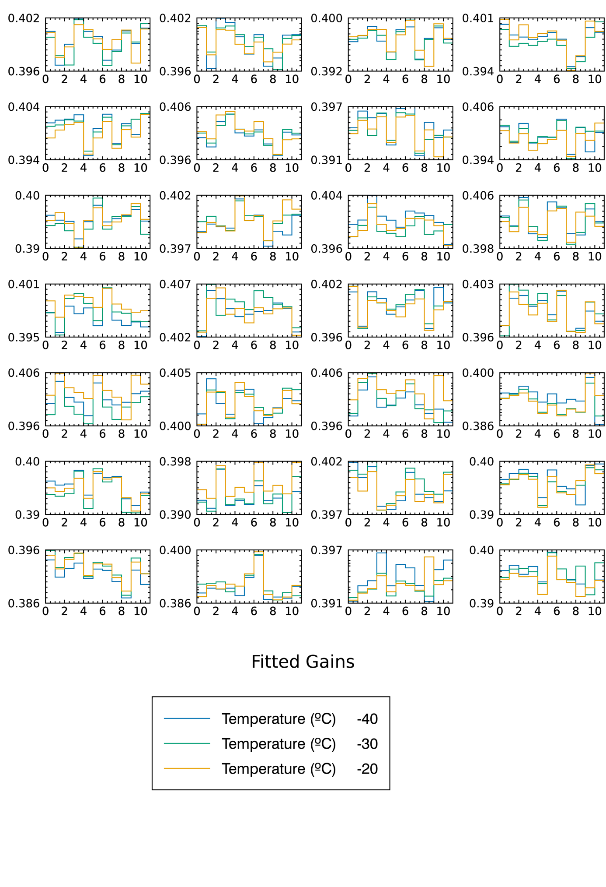

Figure 5: All fitted gains for every pixel for each detector for runs varying in temperature with peaking time constant at 2 μs and voltage 300 V

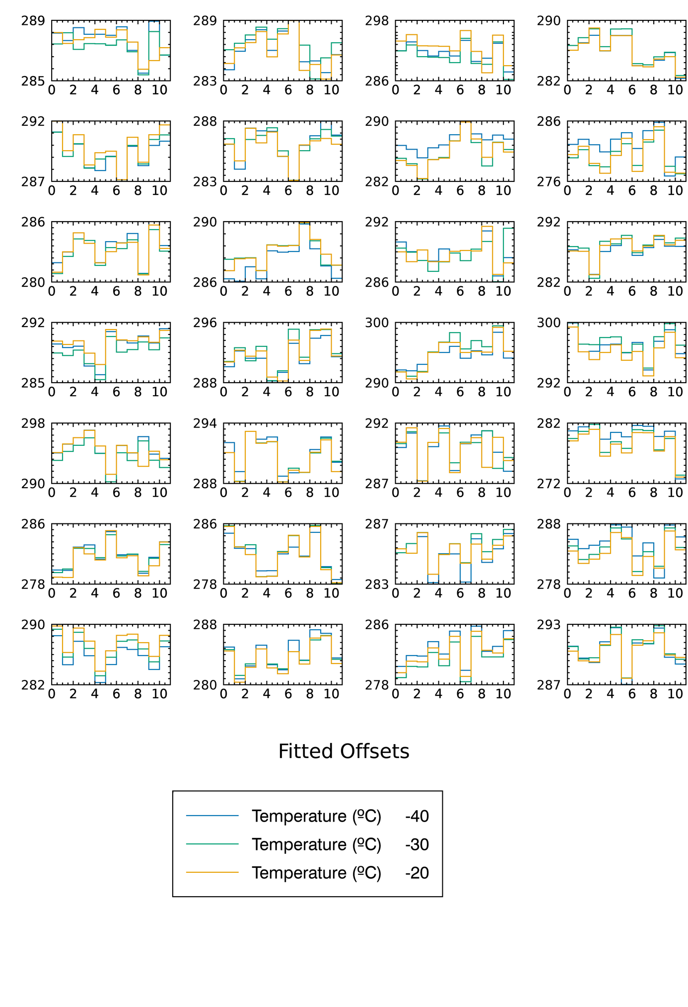Figure 6: All fitted offsets for every pixel for each detector for runs varying in temperature with peaking time constant at 2 μs and voltage 300 V

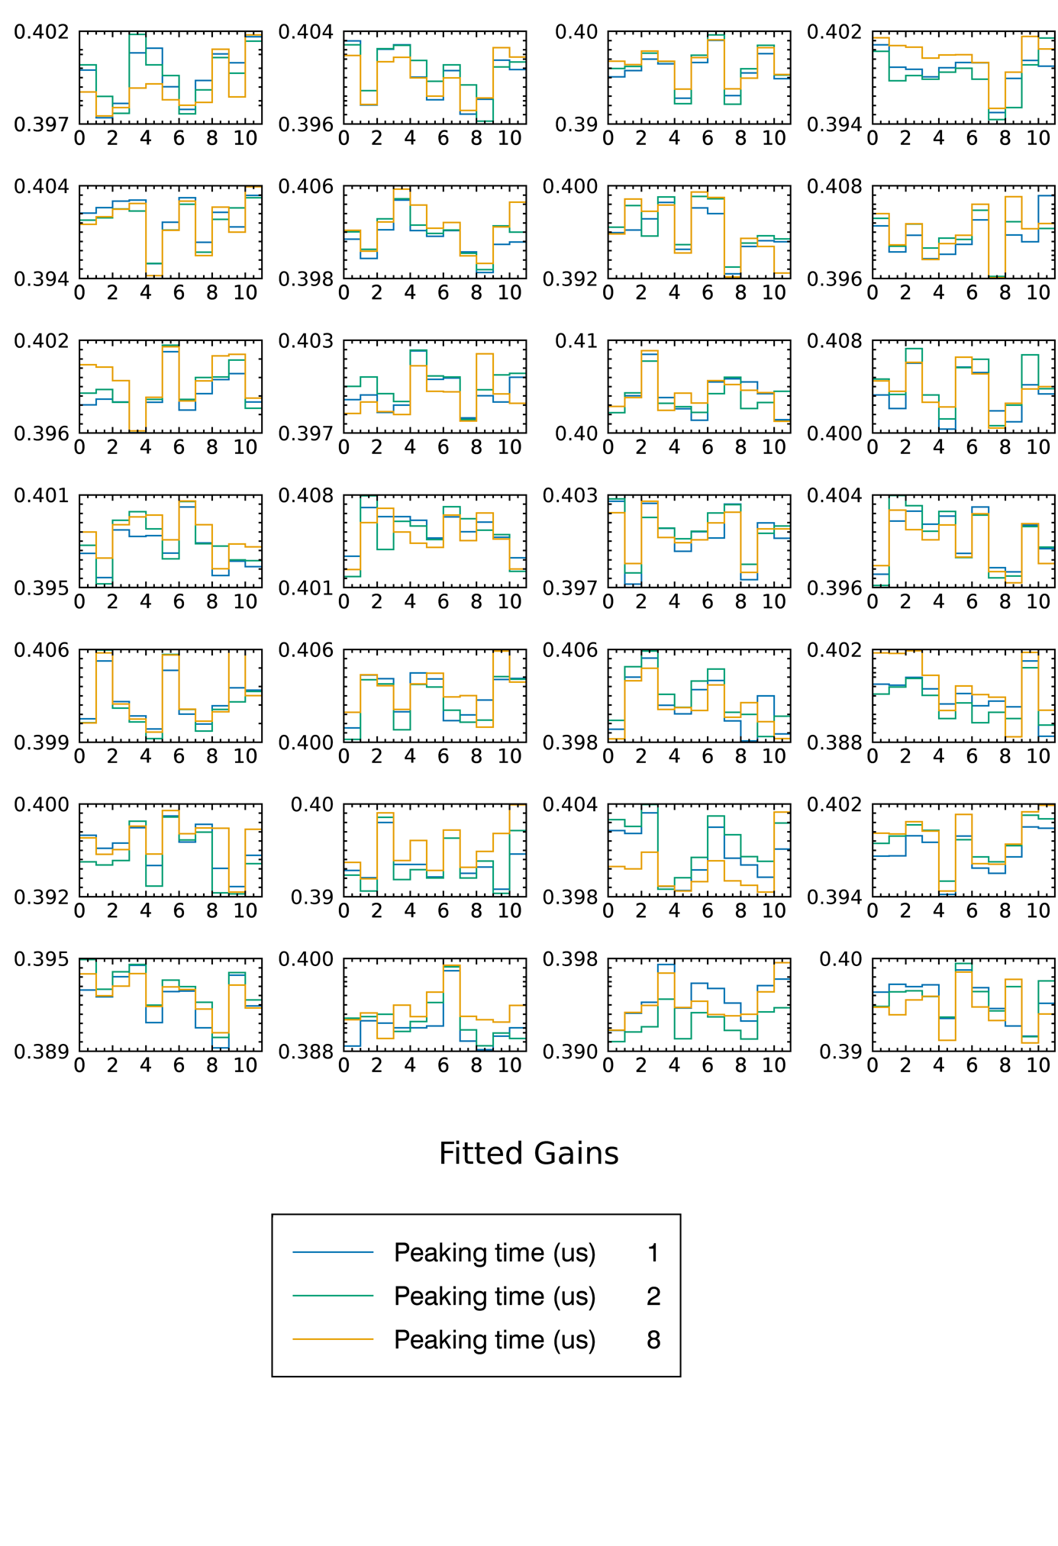Figure 7: All fitted gains for every pixel for each detector for runs varying in peaking time with temperature constant at -30 ºC and voltage 300 V

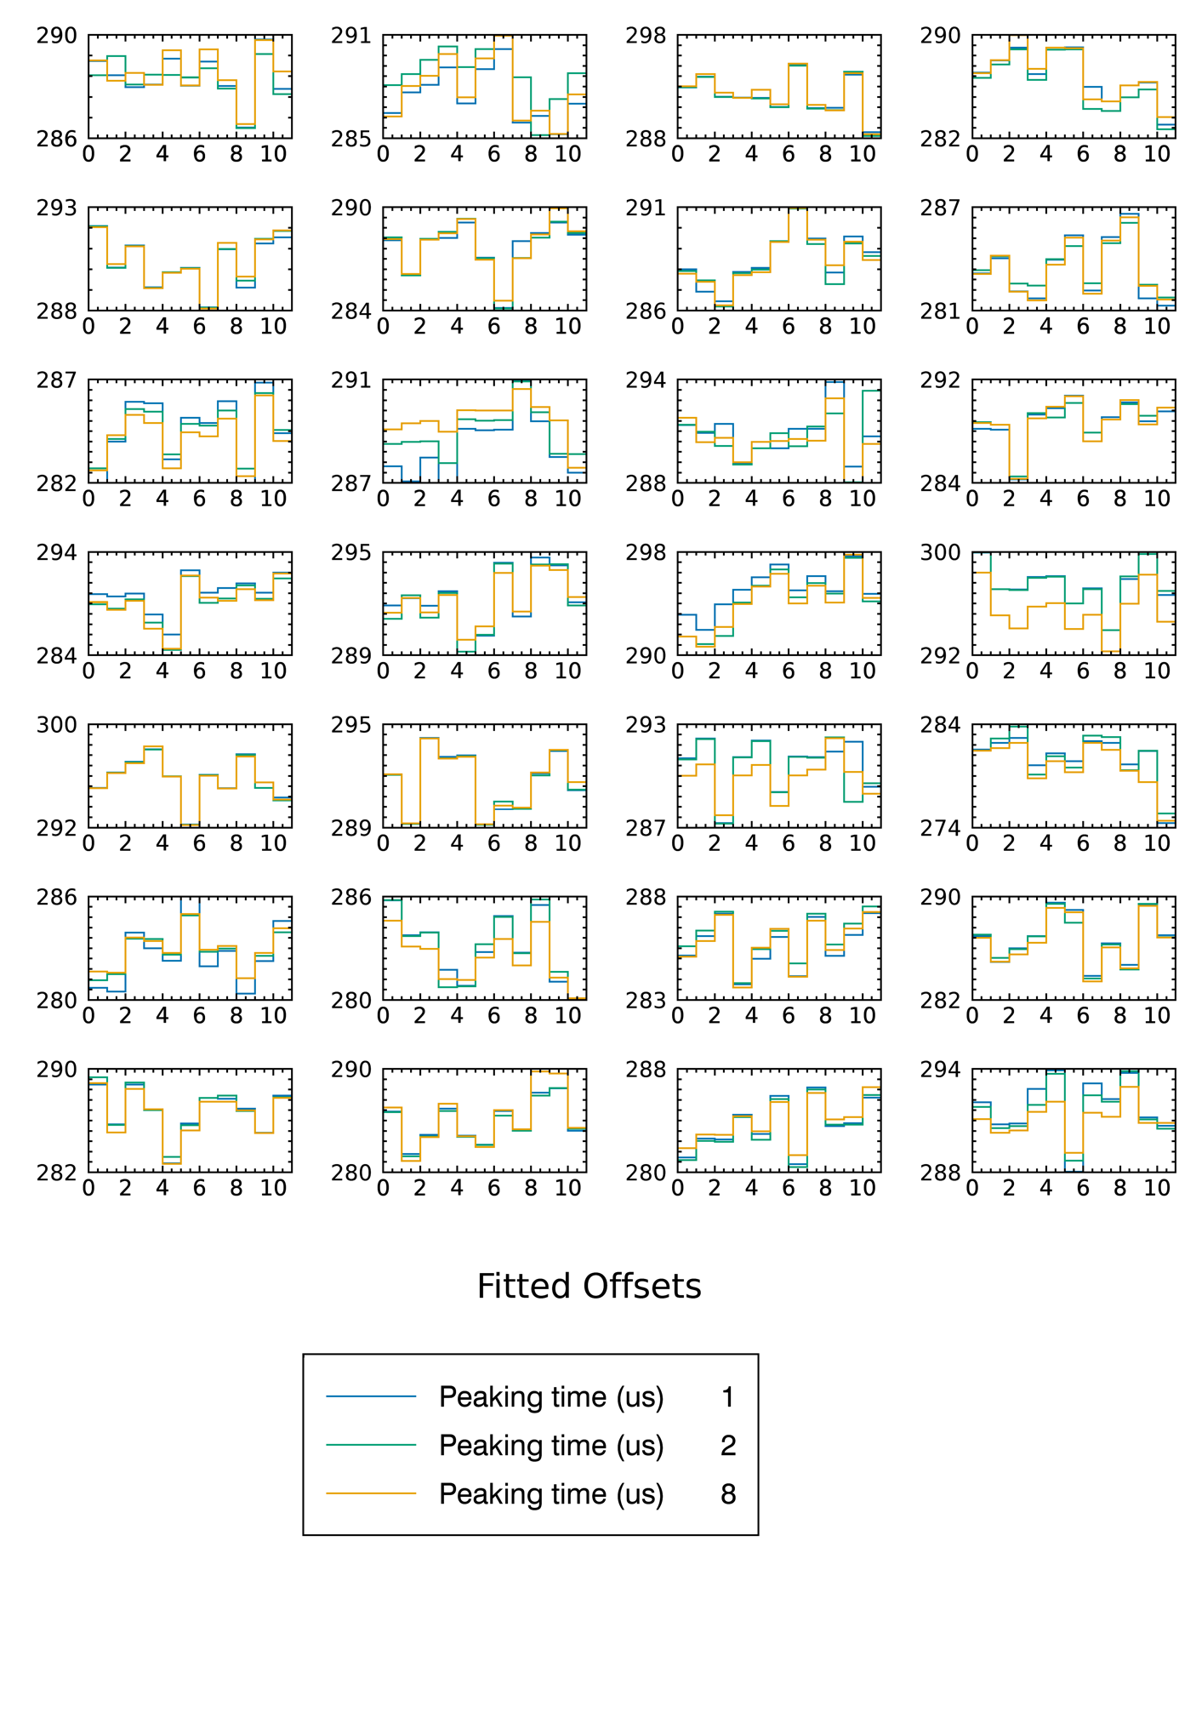

Figure 8 All fitted offsets for every pixel for each detector for runs varying in peaking time with temperature constant at -30 ºC and voltage 300 V

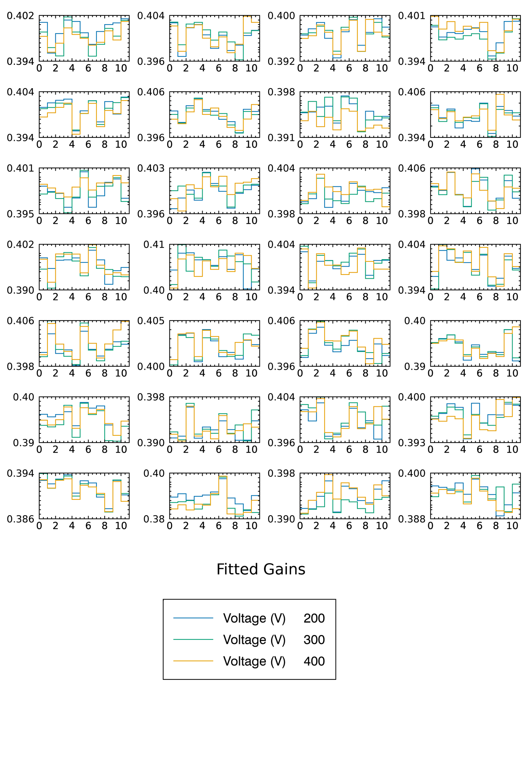

Figure 9: All fitted gains for every pixel for each detector for runs varying in voltage with temperature constant at -30 ºC and peaking time constant at 2 μs

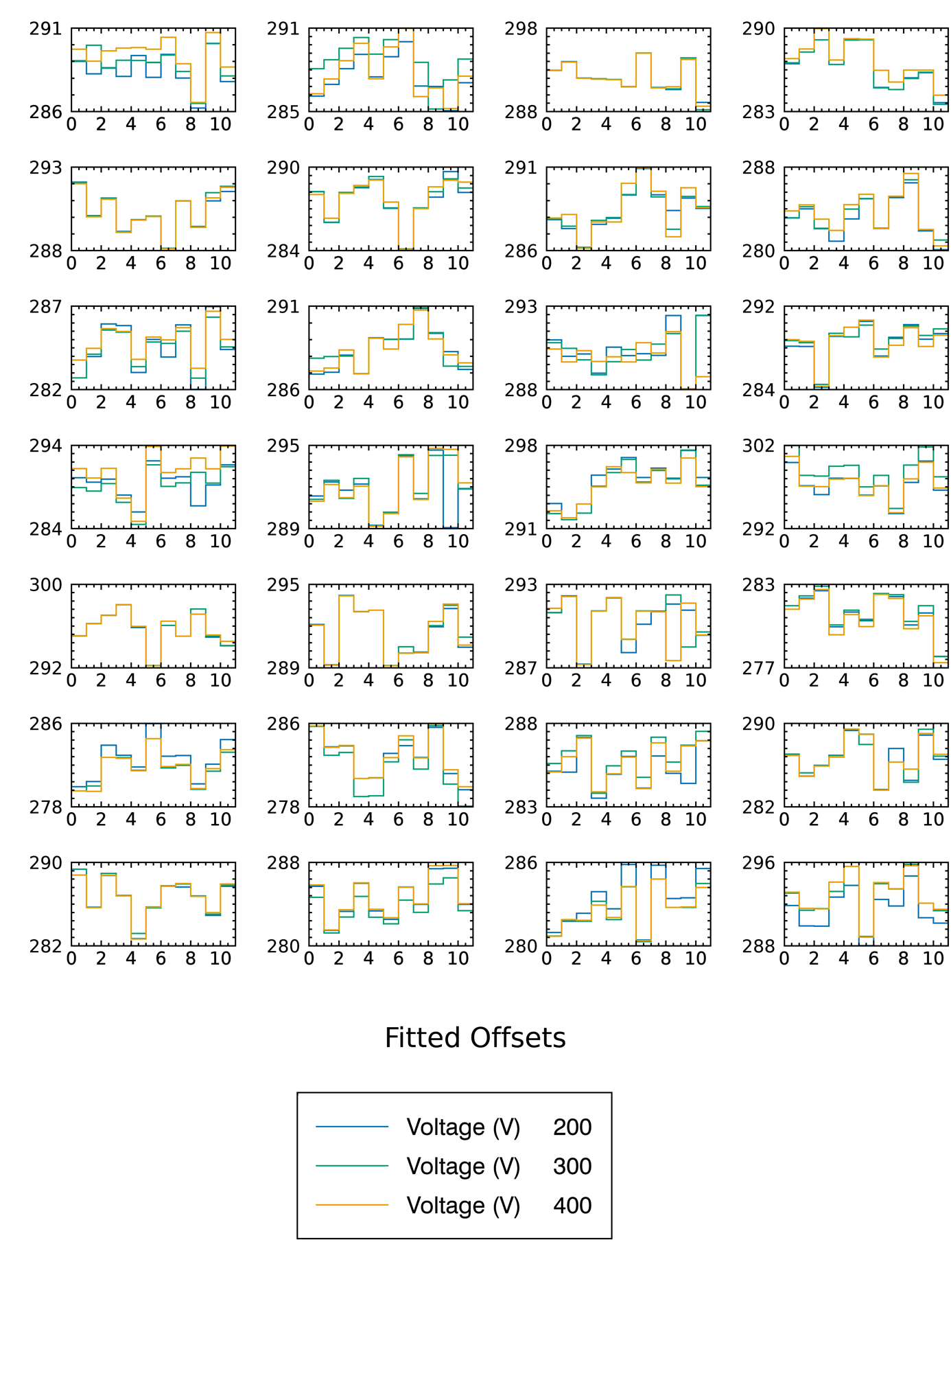

Figure 10: All fitted gains for every pixel for each detector for runs varying in voltage with temperature constant at -30 ºC and peaking time constant at 2 μs

## Comparison with CEA calibration

As part of the testing procedure at CEA detailed calibration estimates for every pixel under a variety of conditions were made. This time using an Americium 241 source which is different again from either the performance study or the in-flight calibration. These values were converted using the same procedure as was used to create the STIX telemetry files to give estimates of the expected offset and gain in terms of the 1024 telemetry bins.

Expected_gain = cea_gain_scaling * 0.4/cea_gain

loc = (cea_gain* 6.4 + cea_offset - cea_offset_scaling )/( cea_gain_scaling * 0.4) + 288

Expected_offset = loc – 6.4/Expected_gain

These estimates were then compared with the fitted values of gain and offset for the same conditions. The calibration tests were performed using the same temperature and peaking time values as the performance study but all repetitions were done using a voltage of 300 V (Table 2). When comparing the CEA calibration results with the OSPEX results derived here for cases where the voltage is different from 300 V the CEA run using the same temperature and peaking time but with a voltage of 300 V is used.

As an example, the offset and gain for all detector pixels for one run are plotted simultaneously (Figure 11). It can be seen that the OSPEX derived results agree well with what is expected from the CEA calibration fitting. However, in all cases there appears to be a constant offset between the CEA and OSPEX results.

The percentage difference, calculated as (fit - expected)/expected*100, for all runs fit here were examined and the results for each case seemed to be consisted with a ~0.1% underestimate in the offset and a ~0.2% underestimate in the gain from the fitted OSPEX results (Figure 12 to Figure 18). The comparisons for temperature and peaking time also showed fairly narrow profiles with very few outliers showing a discrepancy greater that 0.5% including the constant offset.

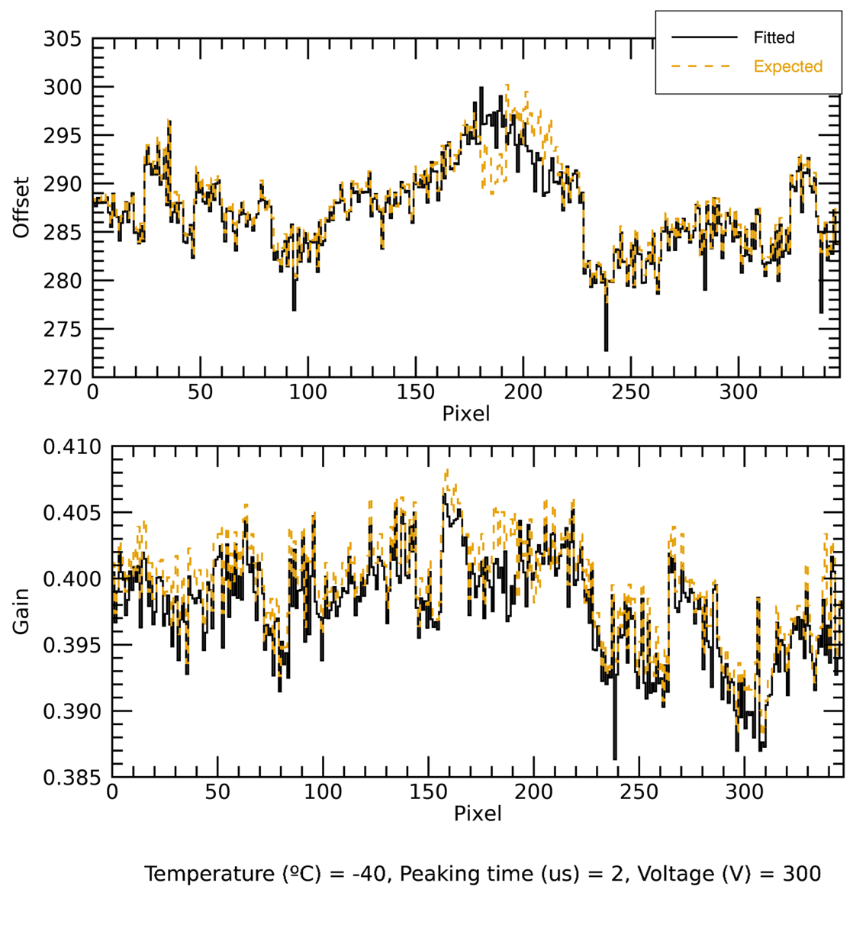

Figure 11: Comparison of expected values (yellow, dashed) and OSPEX fitted values (black, solid) of offset (top) and gain (bottom) for all detector pixels for a single test run at a given temperature, peaking time and voltage.

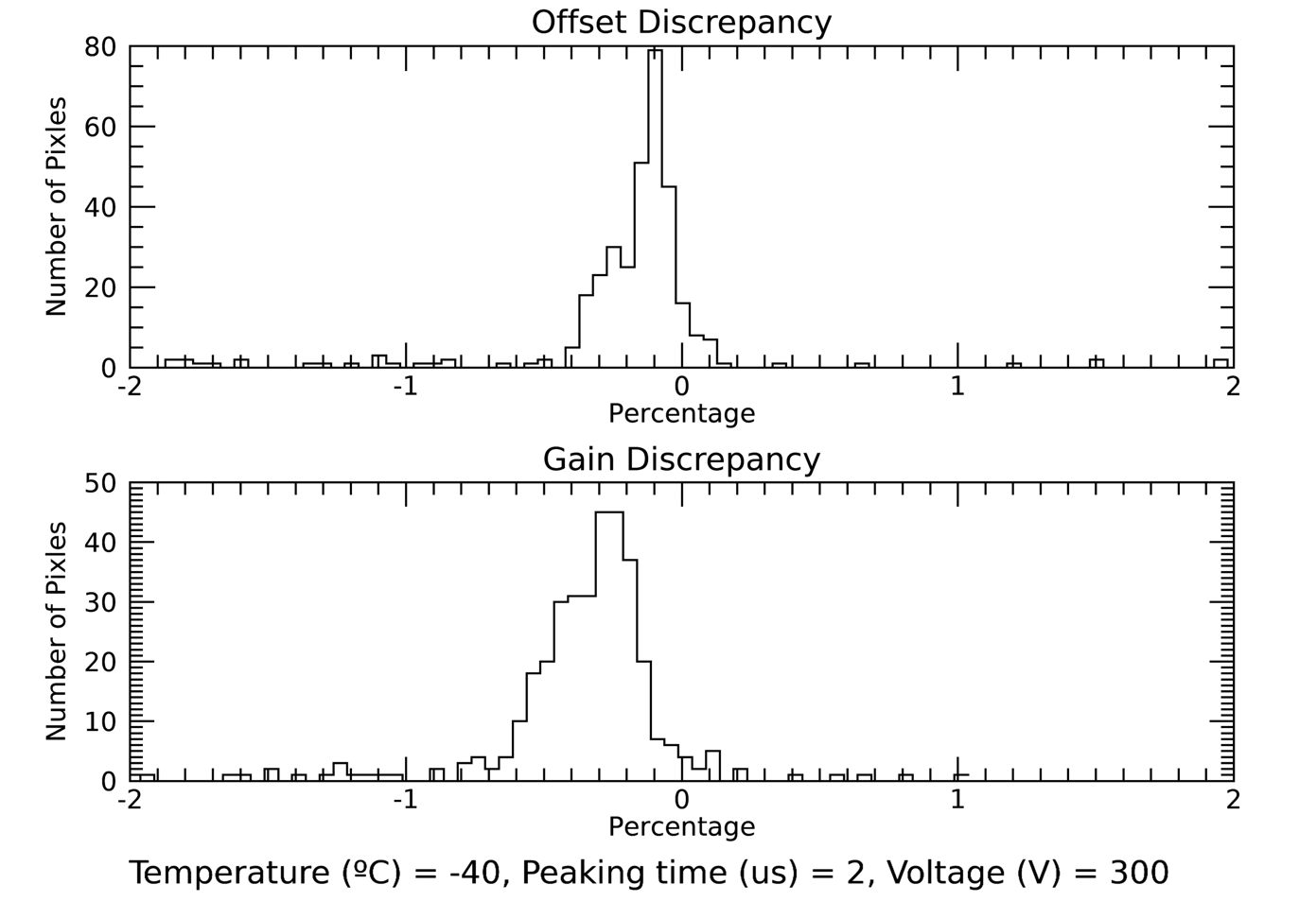

Figure 12: Percentage discrepancy ((fit - expected)/expected*100 ) between CEA calibration parameters and OSEPX fit calibration parameters for one test run.

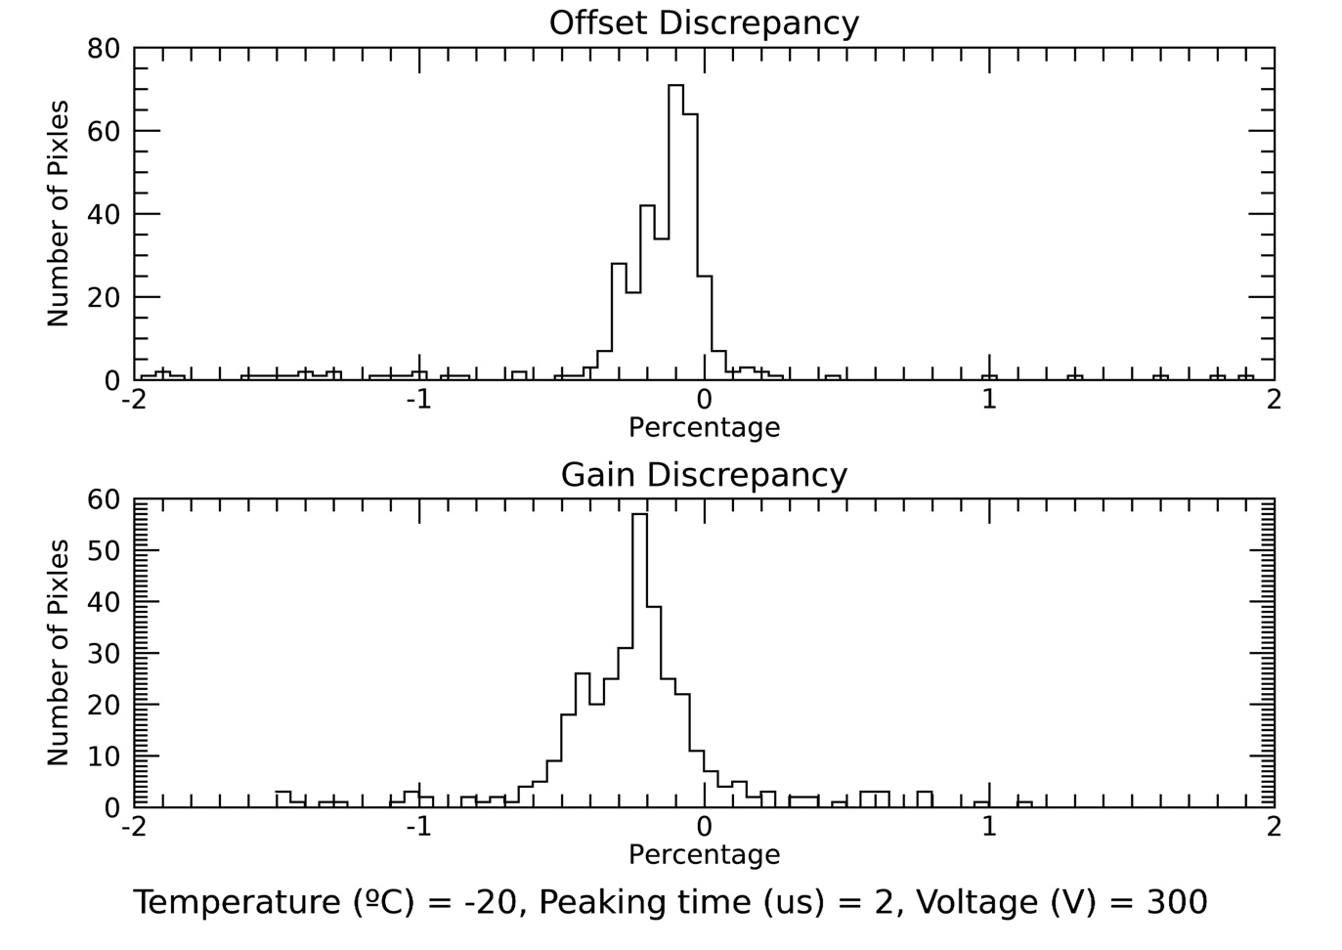

Figure 13: Percentage discrepancy between CEA calibration parameters and OSEPX fit calibration parameters for one test run.

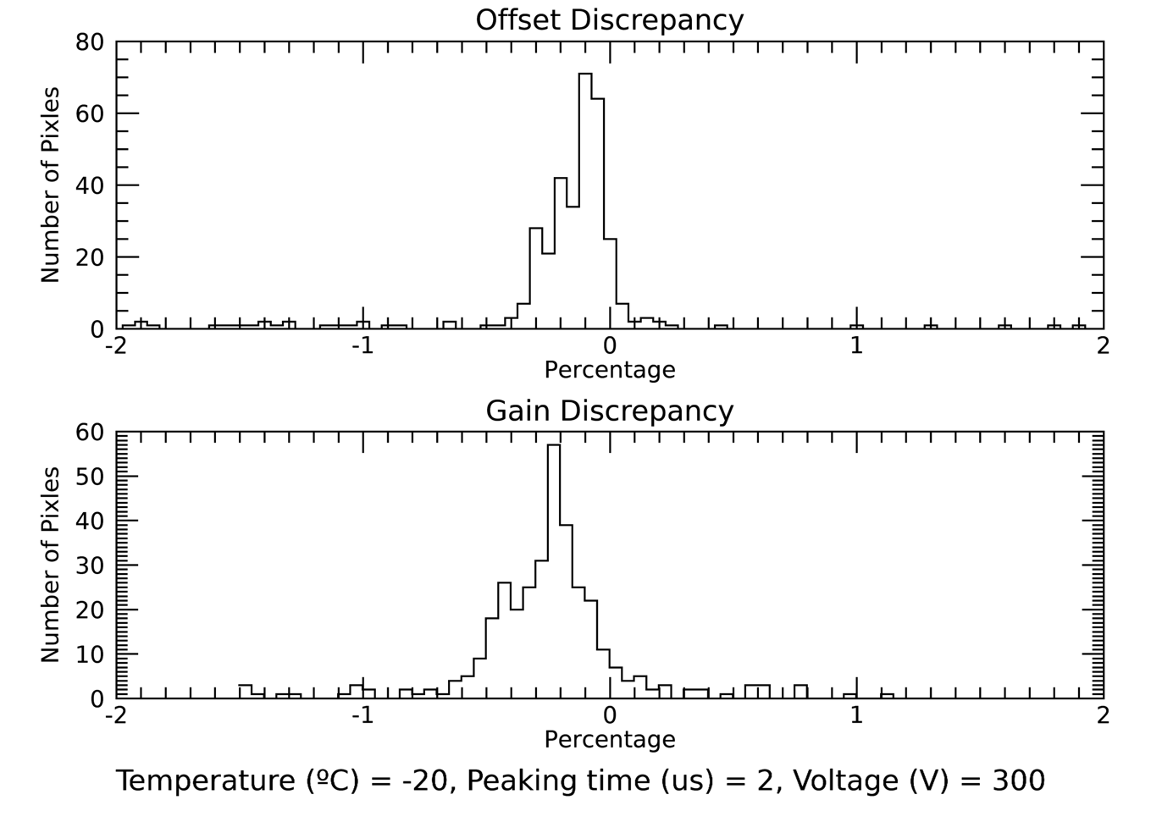

Figure 14: Percentage discrepancy between CEA calibration parameters and OSEPX fit calibration parameters for one test run.

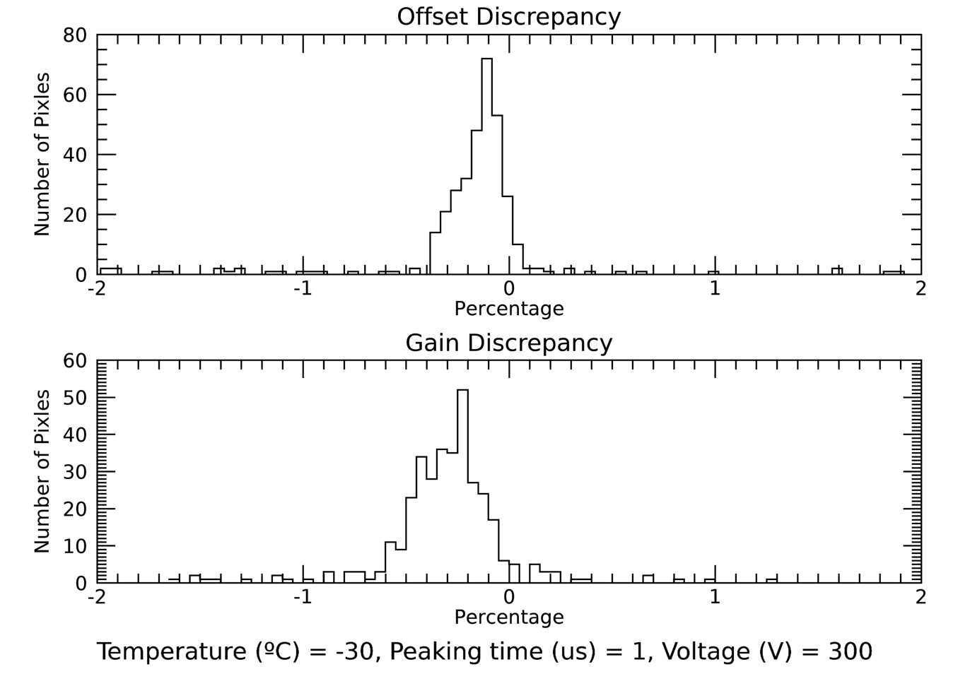

Figure 15: Percentage discrepancy between CEA calibration parameters and OSEPX fit calibration parameters for one test run.

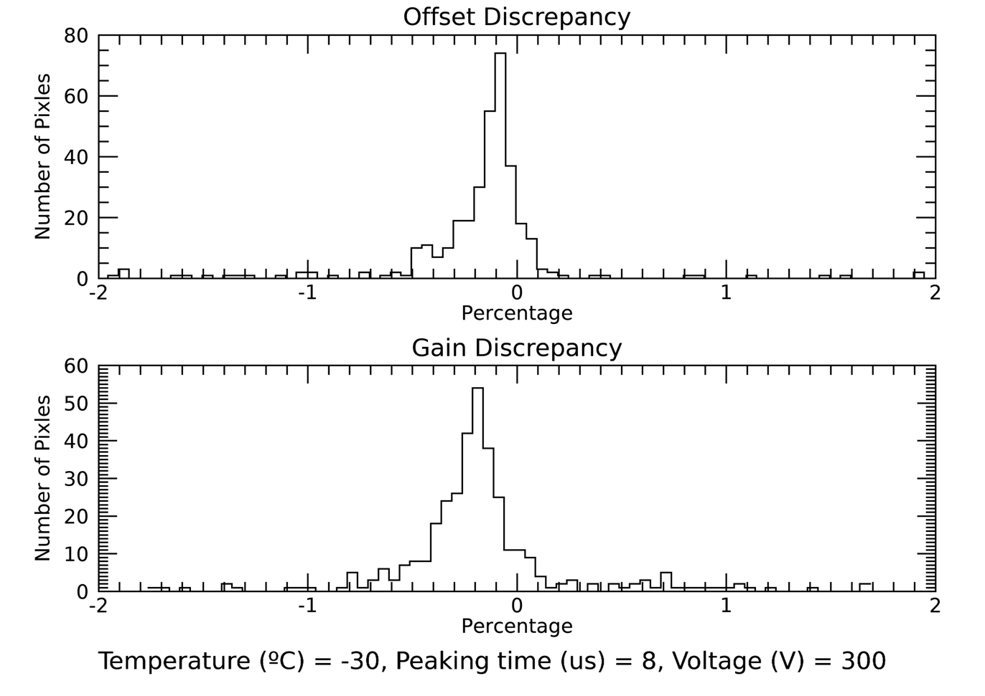

Figure 16: Percentage discrepancy between CEA calibration parameters and OSEPX fit calibration parameters for one test run.

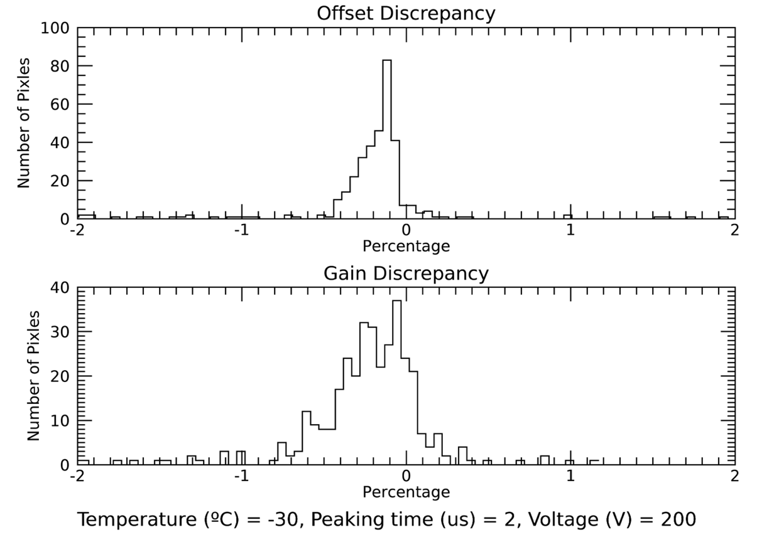

Figure 17: Percentage discrepancy between CEA calibration parameters and OSEPX fit calibration parameters for one test run.

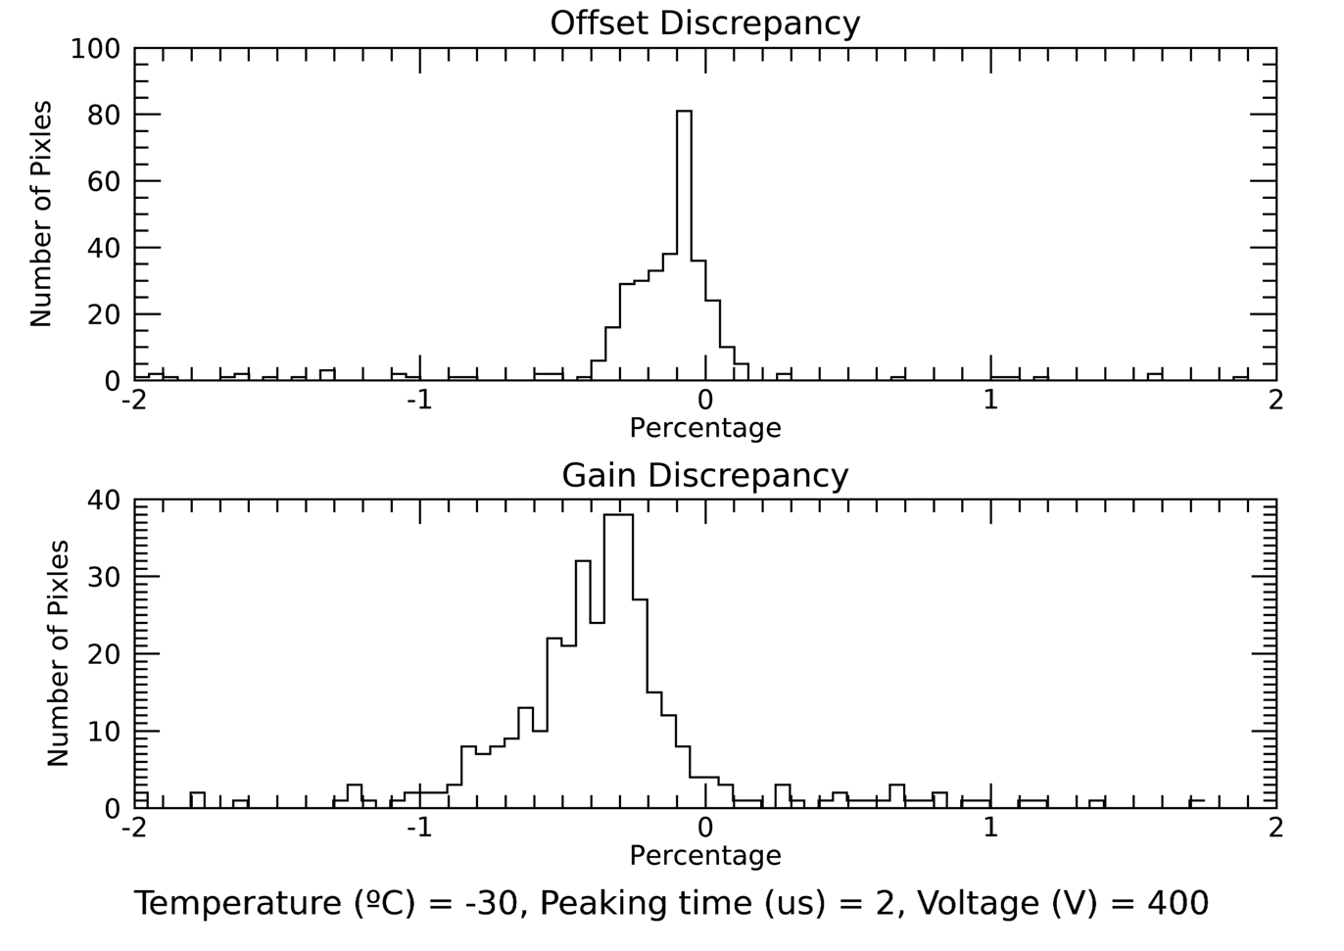

Figure 18 Percentage discrepancy between CEA calibration parameters and OSEPX fit calibration parameters for one test run.

## Trends due to detector conditions

As the CEA dataset contains spectral data taken under a range of conditions trends in offset and gain over temperature, voltage and peaking time can be examined. As there is a possibility that some calibration lines could be misidentified by the fitting procedure an outlier resistant mean (resistant_mean.pro) was calculated over all detector pixels for the offset and gain for each run. As the small pixels have significantly fewer counts and therefore less reliable fits the means for small and large pixels were also calculated separately.

For the vast majority of parameters the trend is the same between small, big and all pixels and also from the mean of the expected parameter values determined from the CEA calibration data however the constant offsets between the CEA parameters and the OSPEX fitted results is also apparent in the means (Figure 19 and Figure 20).

As the CEA calibration data was only taken at one voltage there is no expected trend. Here the constant value of the CEA offset and gain taken from data with voltage at 300 V is compared with the OSPEX fits to the performance study data with the same temperature and peaking time but for 200, 300 and 400 V (Figure 21).

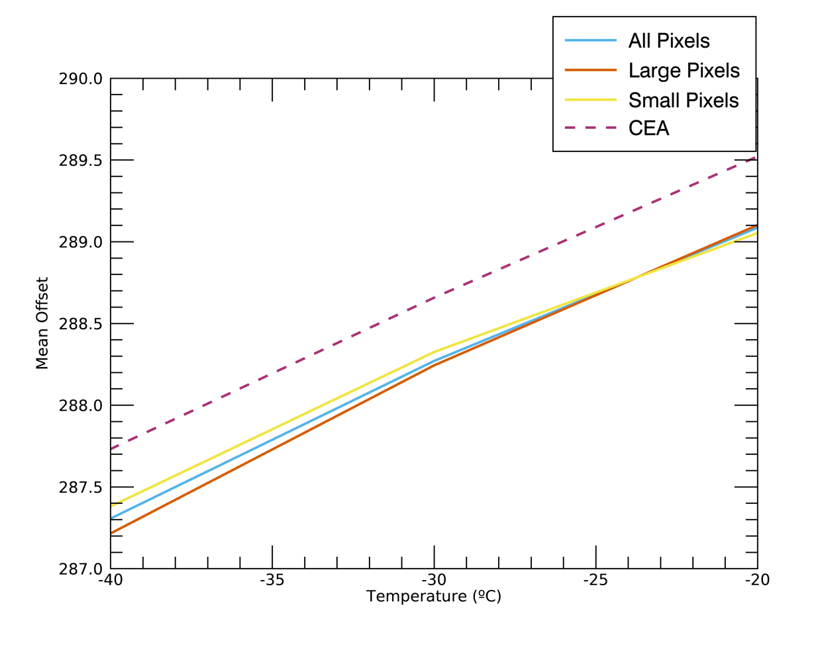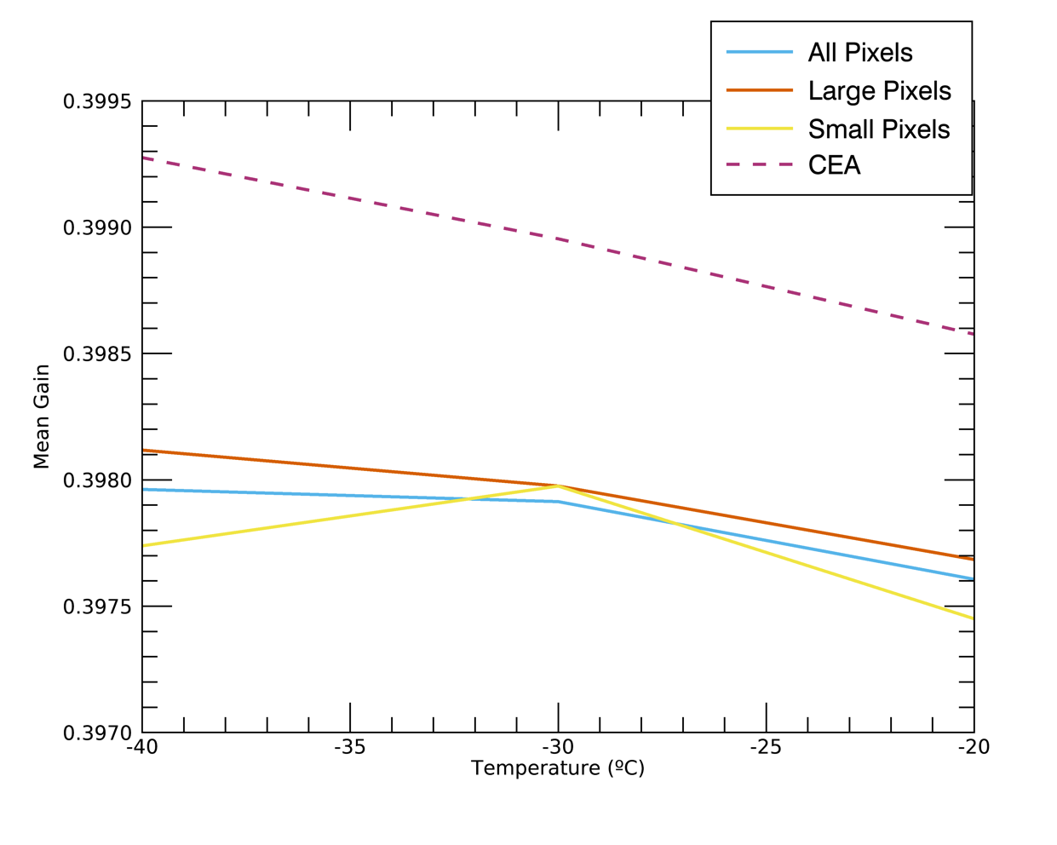

Figure 19: Average offset (top) and gain (bottom) for the test runs varying in temperature. The mean value for these runs from the expected parameters based on the CEA data is also plotted (dashed, purple)

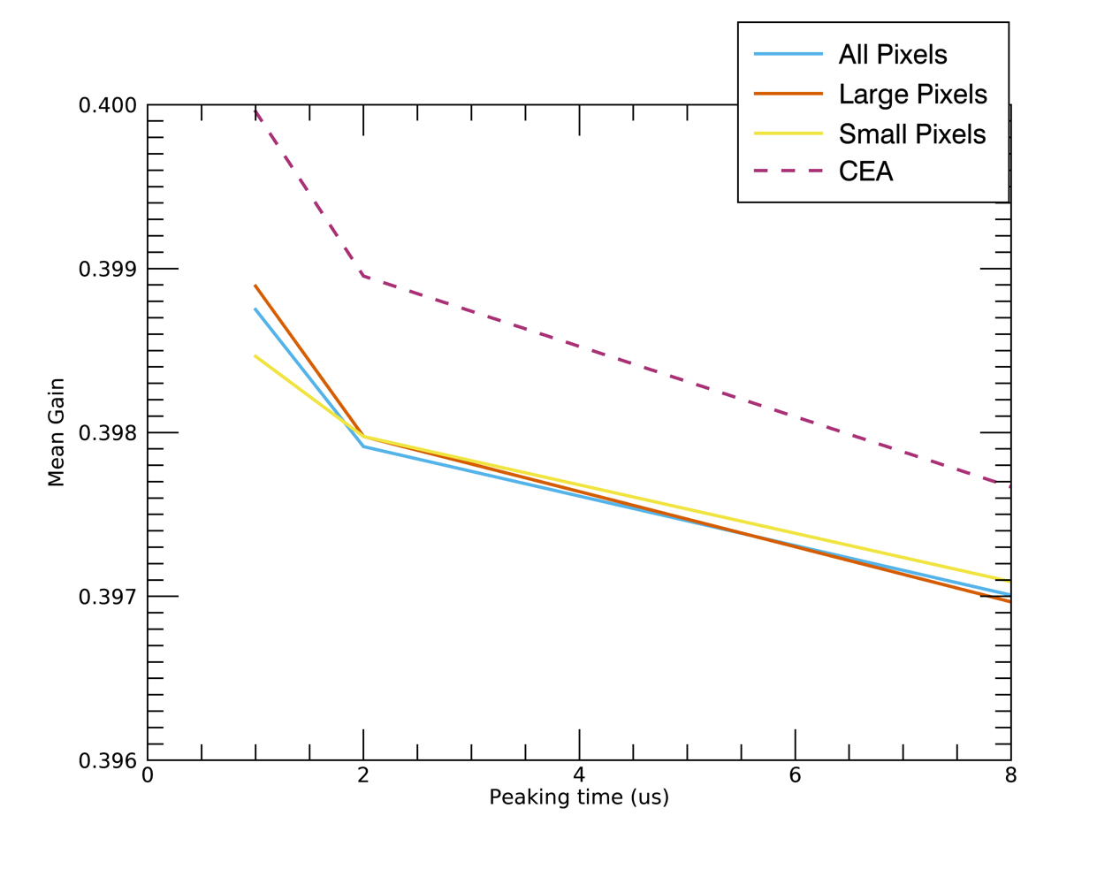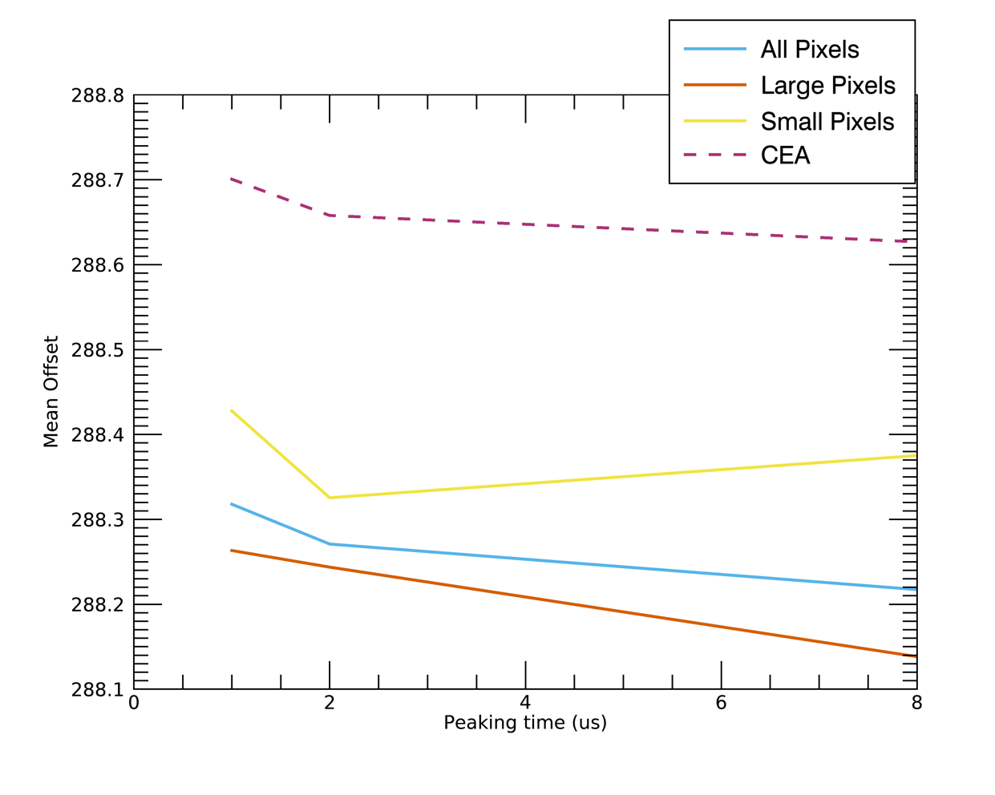

Figure 20: Average offset (top) and gain (bottom) for the test runs varying in PEaking. The mean value for these runs from the expected parameters based on the CEA data is also plotted (dashed, purple)

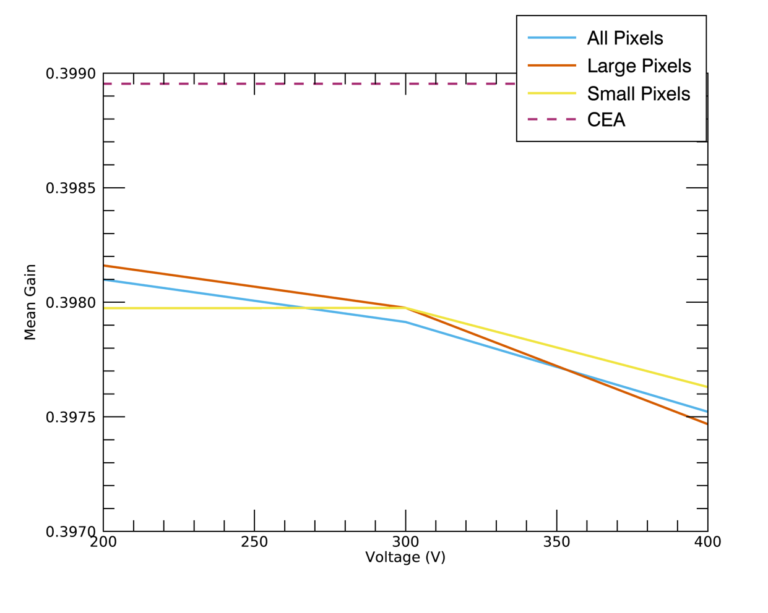

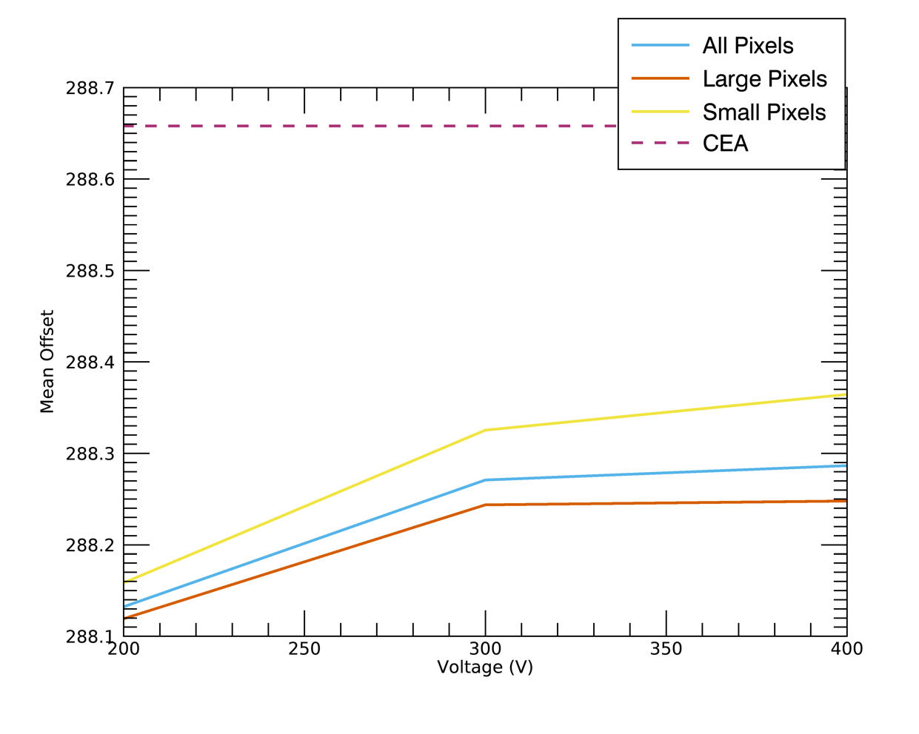

Figure 21: Average offset (top) and gain (bottom) for the test runs varying in temperature. The mean value for these runs from the expected parameters based on the CEA data is also plotted (dashed, purple) as the calibration data was all taken with a voltage of 300V a constant average is reported for all runs.